Which way is the wind blowing? Take a moment to reflect on what your club is doing well and what things you might change. Are you sharing those things you’re doing well and taking steps to change the others?

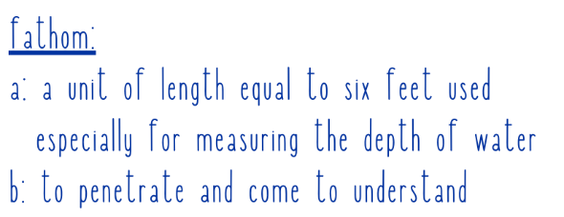

What can you hardly fathom that you want to achieve? Club president, county president? Write down your dream and have the confidence to make it a reality.

Leading and encouraging others is integral to KEHA. What are three things that you are doing RIGHT to build confidence in your fellow homemakers?
1.
2.
3.
Milestone Journal
2022
NAME:_________________________________________

KEHA is an important part of your story. Use this Milestone Journal to guide your thoughts and feelings as you reflect on the many ways that your experience with your fellow homemakers has anchored and shaped you to confidently become the person you are today!
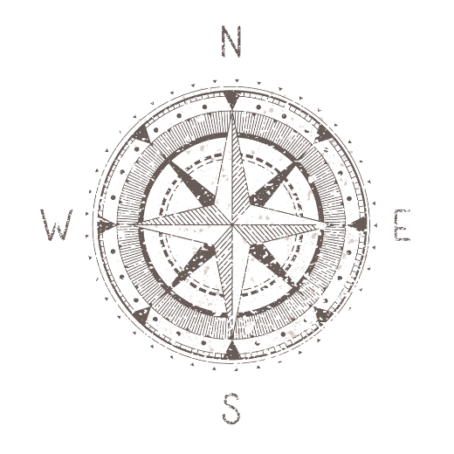

Share what guides you to confidently achieve your goals. Keep looking up like the meridian lines headed to the North Pole.

What is your BIG idea for moving your homemaker club membership to the next level? Remember to share your idea at your next club meeting. Just think what a “tidal wave” your county will experience if each club implements one idea.
_____________________________________________________
_____________________________________________________
_____________________________________________________
Invite three friends to take the plunge and join KEHA!
My friends’ names: Did they join?
YES NO
YES NO
YES NO
(Remember, gift certificates are available for giving the gift of membership.)

Sharing ourselves is a core value of KEHA as a volunteer organization. What are you doing to leave a mark on your community? The ripples will spread like the wake behind a boat.

