KEHA Brand Guidelines
In May 2018, the Kentucky Extension Homemakers Association adopted a new logo for use by the association at all levels (club, county, area and state). The new logo represents the first brand update in decades. The logo includes a fresh, new color palette and an emphasis on the word ‘homemakers’. There are three versions of the new logo available for club, county, area and statewide use as described below.

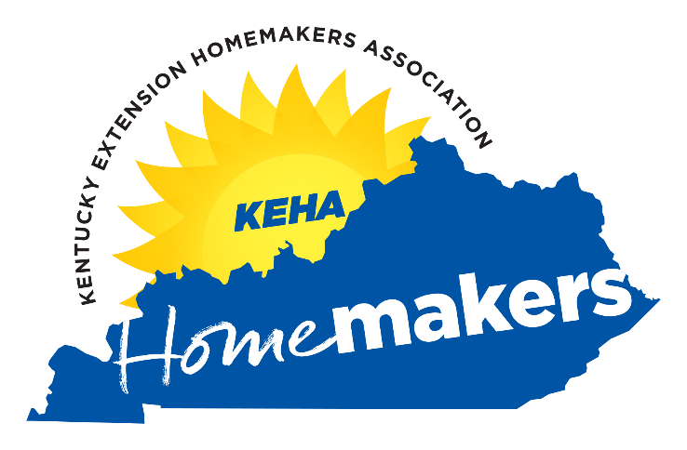
Full Color Logo
The full-color logo pictured at right is for use in any applications where printing will be in color. It is also recommended for use in digital platforms like websites and social media accounts. Both jpg and png files are available for download by Extension personnel via the Family and Consumer Sciences Extension internal/agent resource web page. The files are housed in this location as it requires a password for access. KEHA leaders in need of the graphic file should work with their county Extension office to download the high-resolution digital file.

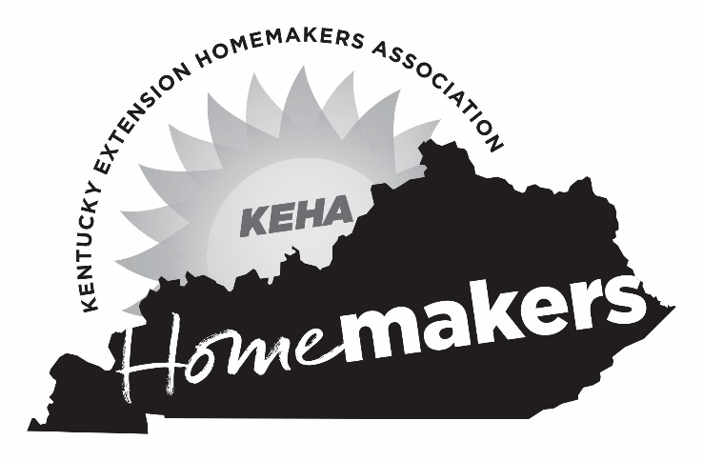
Grayscale Logo
The grayscale logo pictured at right is for use in any applications were printing will be in black and white or grayscale. Often newsletters, programs and other materials are printed black and white versus in full color. This version of the logo will work best for those materials. Both jpg and png files are available for download by Extension personnel via the Family and Consumer Sciences Extension internal/agent resource web page. The files are housed in this location as it requires a password for access. KEHA leaders in need of the graphic file should work with their county Extension office to download the high-resolution digital file.

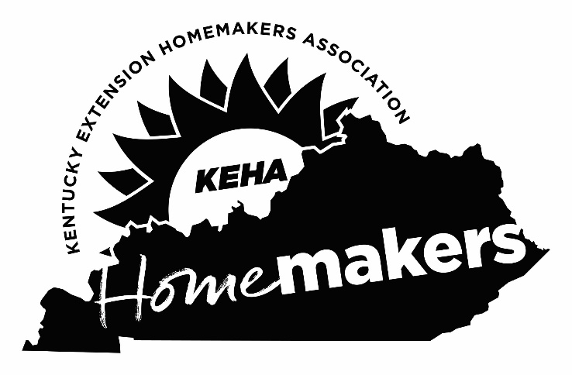
Single Color Logo
The single color logo pictured at right is for use with imprinted items with one-color imprint. If you are ordering t-shirts, tote bags or any other type of promotional materials with one-color imprinting, this version of the logo will work best for those items. Both jpg and png files are available for download by Extension personnel via the Family and Consumer Sciences Extension internal/agent resource web page. The files are housed in this location as it requires a password for access. KEHA leaders in need of the graphic file should work with their county Extension office to download the high-resolution digital file.

Logo Colors
The full-color logo file incorporates blue, black and two shades of yellow. To match text and graphic elements to the blue and yellow logo colors, please use the RGB colors as defined below.
Blue: R:0 G:84 B:166
Yellow 1 (darker sun rays): R:225 G:206 B:12
Yellow 2 (lighter sun rays and circle): R:255 G:241 B:59

Complimentary Fonts
The following fonts are recommended for use with the logo: Helvetica Bold and Arial Bold. These basic fonts are available in most software programs. In addition, AvenirNext Bold (available to University of Kentucky personnel) is also recommended.

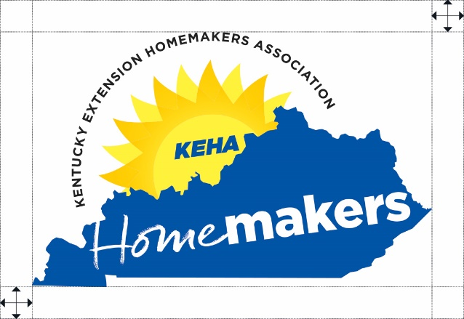
Logo Placement
To insure that the logo is highly visible, always separate it from surrounding text, images and graphic elements. The suggested buffer zone is, at minimum, ¼ inch on all sides (see illustration). The buffer zone should increase as the size of the logo increases. For example, if you are printing a flyer with the logo sized at 4 inches tall by 6.1 inches wide, increase the buffer zone to greater than ½ inch.
Sizing and Scaling the Full Logo
Regardless of which version of the full logo you use, it should be no smaller than 1.5 inches tall by 2.29 inches wide. When re-sizing please be sure you maintain the aspect ratio. Do not stretch, skew, rotate or recolor the logo. (See examples of what not to do on page 4.)

Small-Scale Printing
If you are developing a handout to print or purchasing a promotional item that does not provide space for use of the logo at a minimum size of 1.5 inches tall by 2.29 inches wide, an alternate logo is available. This alternate version is ideal for use on nametags, pins and promotional items with a small imprint area. The alternate image (see below) is available in both blue and black versions. The files (jpg images) are available for download by Extension personnel via the Family and Consumer Sciences Extension internal/agent resource web page. The files are housed in this location as it requires a password for access. KEHA leaders in need of the graphic file should work with their county Extension office to download the high-resolution digital file.
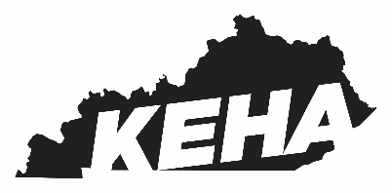
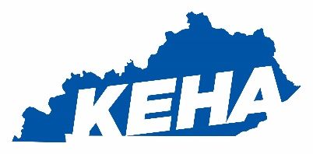

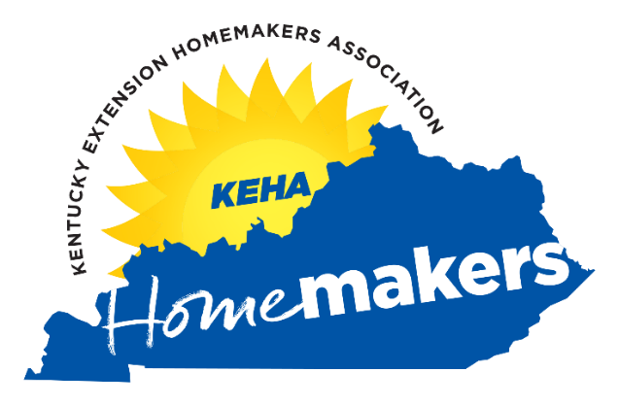
Best County Extension Homemakers
Personalizing for Club, County or Area
The logo graphic should not be altered in any way. To personalize for your club, county or area, we recommend adding text beneath the image using one of the complimentary fonts suggested on page 2 (see example at right).

Special Uses
If you have a question not answered in these guidelines or need a specialized file not currently available for download (.ai, .eps, .svg), please contact Mindy McCulley, KEHA Advisor to the Marketing and Publicity Chair, or Sharon Fields, KEHA Marketing and Publicity Chair, as noted below.
Mindy McCulley Sharon Fields
KEHA Marketing & Publicity Advisor KEHA Marketing & Publicity Chair
859-218-1544 606-922-6229
mindy.mcculley@uky.edu scrawford@kih.net

Tips for What Not to Do

X Do not horizontally scale the logo. X

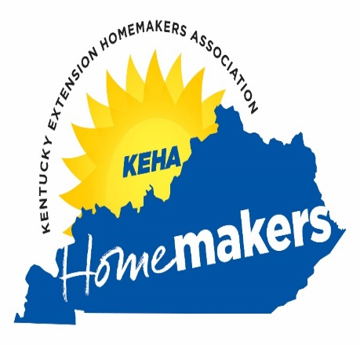

X Do not vertically scale the logo. X

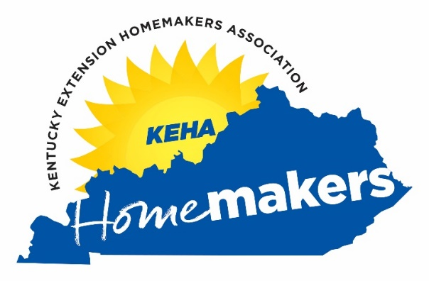

X Do not rotate or tilt the logo. X

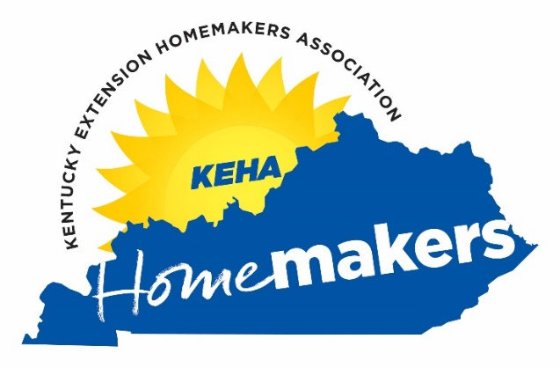

X Do not recolor the logo. X

