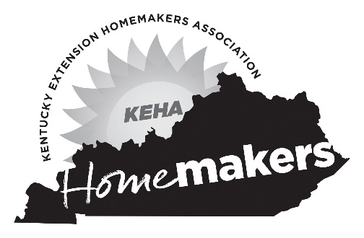
Name: ________________________
County: _______________________
Area: _________________________
KEHA Leadership Academy
Payback Plan of Work Form
Submit by April 3, 2023, to:
Kelly May, KEHA State Advisor, 112 Erikson Hall, Lexington, KY 40506
or k.may@uky.edu

Activity Date(s) | Activity | Anticipated Role(s) or Task(s)

If additional room is needed, please duplicate this page as necessary.

