TRY MORE
Thursday

Don’t get stuck in the “We have always done it THIS WAY” mindset; try to think of new and different approaches to reach potential new members. Take a moment to reflect on what your club is doing well and what things you might change. Are you sharing those things you’re doing well and taking steps to change the others?

FEED THEM
Friday

Today is Feed Them Friday. What information can you feed your community about KEHA? Encourage current members to invite new people to a meeting or a KEHA Activity.

SUNSHINE
Saturday

KEHA week wraps up with Sunshine Saturday! Always Let your light shine and share all the opportunities available with KEHA. What are three things that you are doing RIGHT to build confidence in your fellow homemakers?
1. 2. 3.
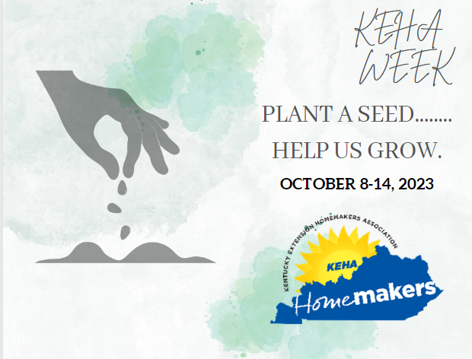
Milestone Journal
2023
NAME:_________________________________________

KEHA is an important part of your story. Use this Milestone Journal to guide your thoughts and feelings as you reflect on the many ways that your experience with your fellow homemakers has nurtured and shaped you to confidently become the person you are today!
MAKE PLANS
Monday

It is Make Plans Monday! Share guidelines on how to make plans to achieve your goals. Try new approaches. Remember SMART goals (specific, measurable, achievable, relevant, and time-bound) are successful goals.

TAKE ACTION
Tuesday

What is your BIG idea for moving your homemaker club membership to the next level? Remember to share your idea at your next club meeting. Just think how your county will grow if each club implements just one idea. _____________________________________________________
_____________________________________________________
_____________________________________________________
Invite three friends to join KEHA and grow the KEHA garden.
My friends’ names: Did they join?
YES NO
YES NO
YES NO
(Remember, gift certificates are available for giving the gift of membership.)
WATER THEM
Wednesday

We’ve made it to Water Them Wednesday! The same as having a new plant, you can’t leave members unattended, it is time to WATER them with the opportunities available through KEHA.

